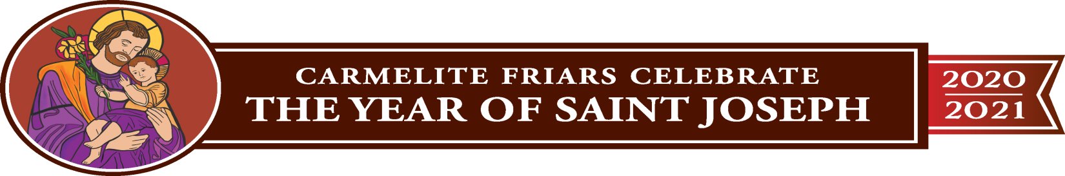
National Shrine of Our Lady of Mount Carmel
A Ministry of the Carmelite Friars of the Saint Elias Province
Pilgrimages and Retreats
Thank you for your inquiry regarding a pilgrimage or day of retreat at The National Shrine of Our Lady of Mount Carmel in Middletown, NY. Our mission statement is as follows:
---To provide a place of pilgrimage and meaningful spiritual experience of God
centered around devotion to Our Lady of Mount Carmel; to offer pilgrims an opportunity for personal experience and growth, reconciliation, learning and meditative prayer
We will work with you to plan a pilgrimage or day of retreat. It can be centered on your own theme, or if you wish, we can provide suggestions for a possible theme. You may also visit our website and sign up for one of our prepared retreat days. If you wish to bring a priest to guide your retreat and celebrate Mass, they are welcome to do so and must provide a letter of suitability from their home Diocesan office prior to the visit if they reside outside the Archdiocese of NY. You may also have someone from your parish guide your retreat, or if you wish, we can provide one of our Carmelite friars or brothers to help with this, as well as myself.
Food options are available according to the size of your group. We have a conference room that has adequate space for 35-40 people, a larger dining hall and an outside picnic area.
When a date is confirmed by phone, we then ask that you send in a $50 non-refundable deposit to hold this date. A facility use fee ranges from $150-$200 which is determined by the length of time of the retreat and the space utilized. In addition, if a group plans to celebrate a private Mass at the Shrine, we would also ask that you take up a collection as a donation to the Shrine. To help with your planning, we wanted you to be aware that the Shrine offers weekday Mass Monday thru Friday at 11:30am and on Sundays at 12:00noon. Confessions are held every Saturdays from 11:00 – 12:00noon. Our Gift Shop is also open Monday thru Friday, 11:00 – 4:00pm; Saturdays, 10:00 – 3:00pm and Sundays, 11:00 – 3:00pm.
The outdoor grounds are filled with many shrines and places of personal prayer or meditation, as well as a picnic area with tables and a large, picturesque lake which all contribute to the peace and serenity that the National Shrine of Our Lady of Mount Carmel has to offer.

We hope to hear from you soon! God Bless you. Carol Bezak, Shrine Director
National Shrine of Our Lady of Mount Carmel
A Ministry of the Carmelite Friars of the Saint Elias Province
70 Carmelite Drive, P.O. Box 2163,
Middletown, NY 10940 845-343-1879 cbezak@carmelites.com www.ourladyofmtcarmelshrine.com

